FOUNDATION UNIVERSITY ISLAMABAD
SCHOOL OF SCIENCE AND TECHNOLOGY

LAB MANUAL 4

NAME: ALISHBA HAFEEZ
SUBJECT: PF(programming fundamentals)
SECTION: 25(B)
ROLL NO: 056
FORM NO: 1025234338
DEPARTMENT: BS IET
INSTRUCTOR: Mr. SHAMSHAIR

TASK 4.1:
Write a C++ program that takes two numbers from the user and tells which number is greater. Your output should be as below.

CODE:
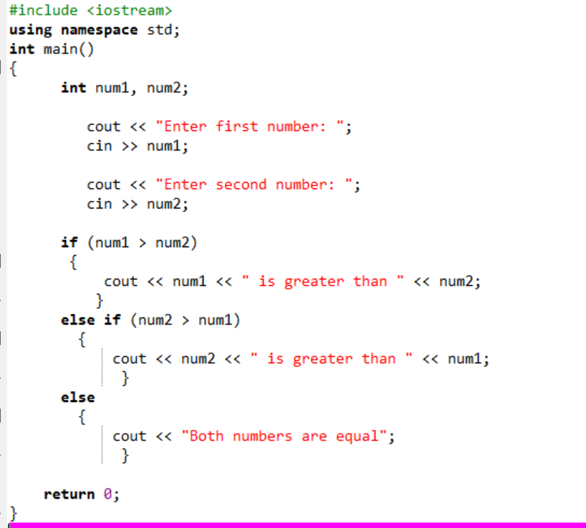
OUTPUT:
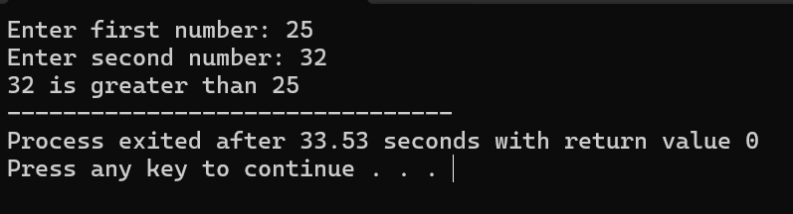

TASK 4.2:
‘if/else’ Statement
Write a C++ program that takes five numbers from the user and finds the largest of these numbers. Your output should be as below.

CODE:
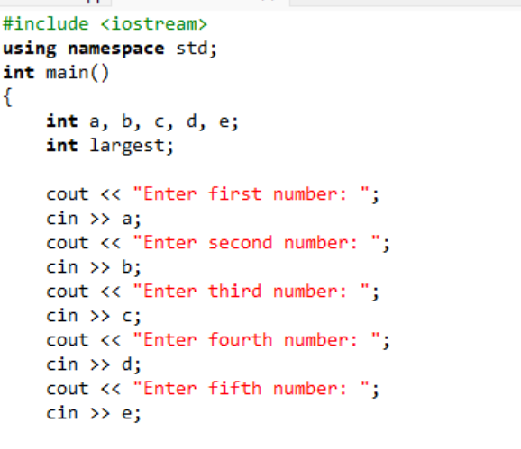
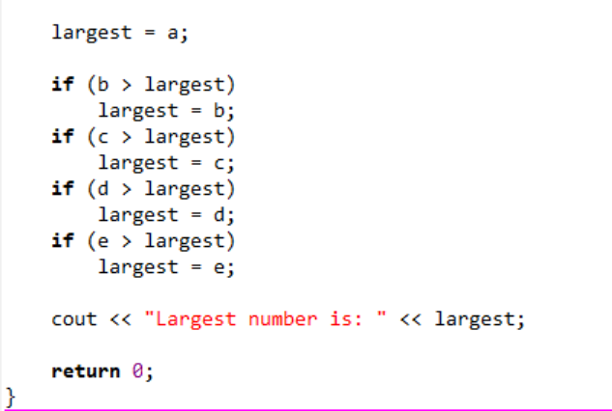
OUTPUT:
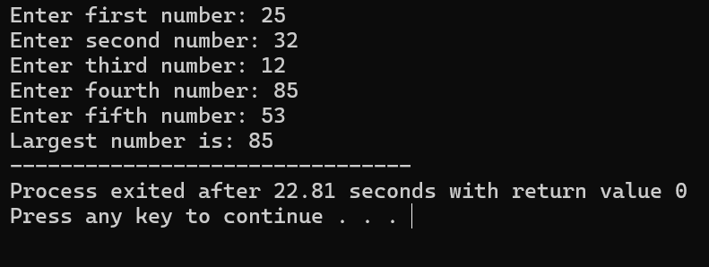

TASK 4.3:
‘Switch’ Statement
Write a C++ program that performs five basic arithmetic operations (+, -, *, /, %). Your program should prompt the user to enter two integers and one character, where the character variable will indicate the specific arithmetic operation to be performed using switch statements.
Hint: In the following example, 5 and 7 are the two integers and + is the character value entered by the user. Based on the value of this character variable, your program should perform the appropriate arithmetic operation. You have to write this program using both ‘if/else’ and ‘switch’ statements, one by one.
The output of your program must be presentable.

CODE: (IF ELSE)
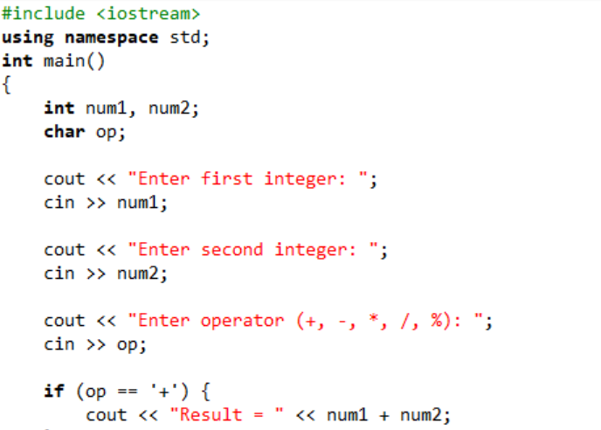
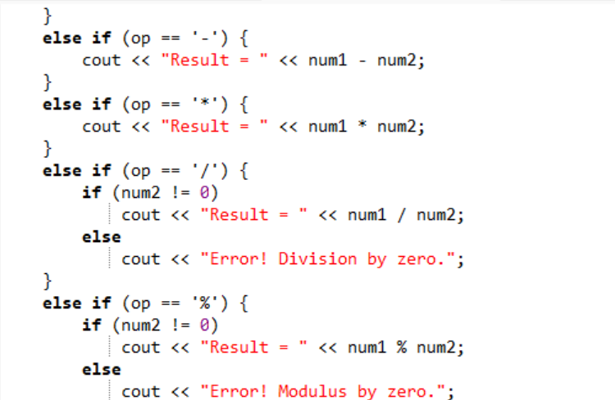
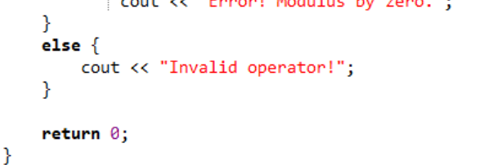

OUTPUT:
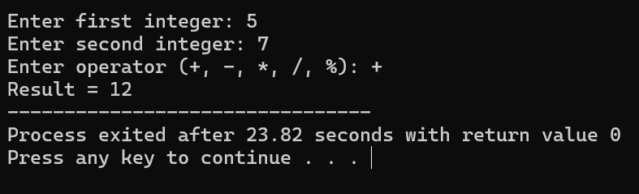

CODE: (SWITCH)
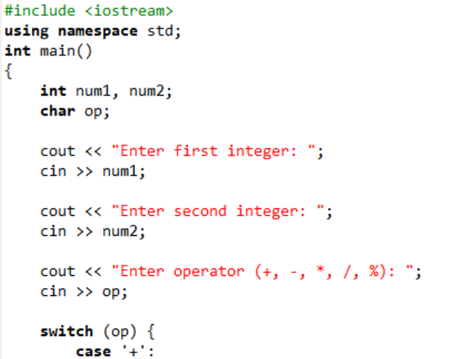
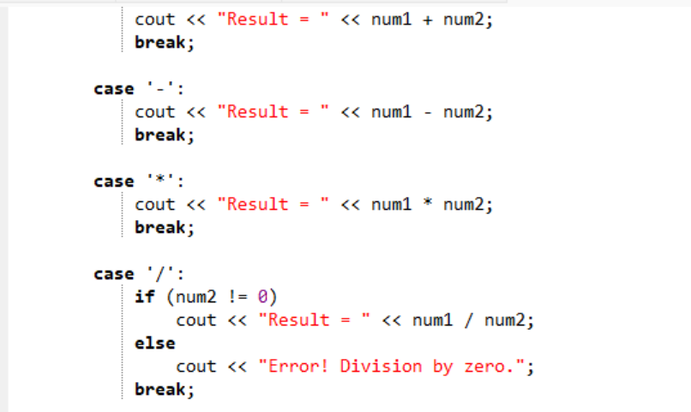
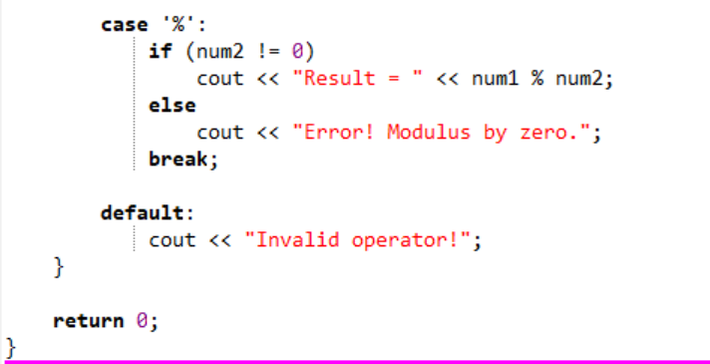

OUTPUT:
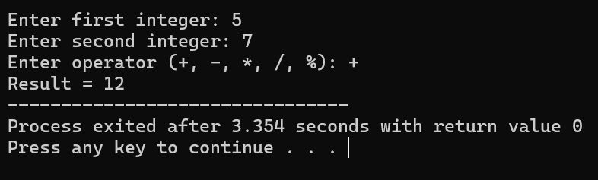

TASK 4.4:
Find the error and show the output of the following code.

CODE:
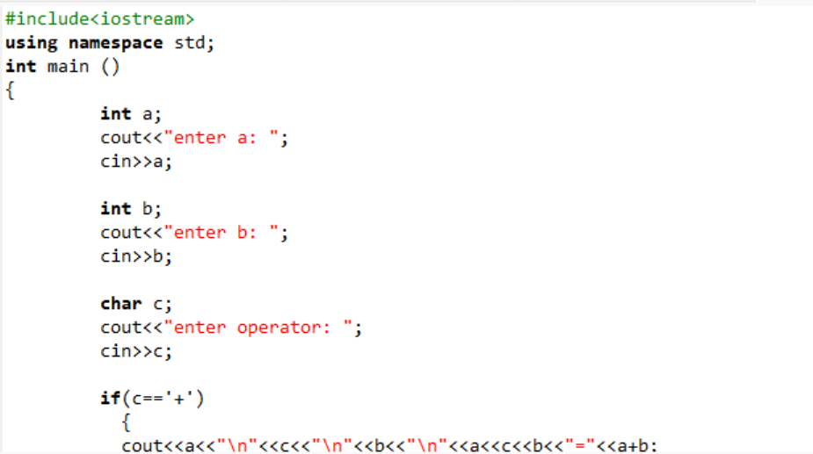
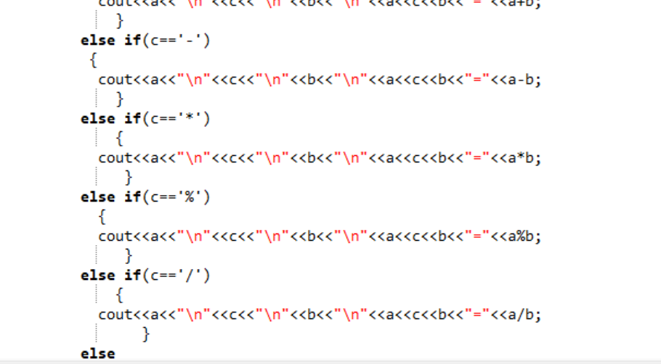
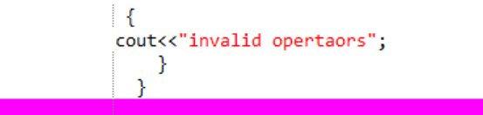

OUTPUT:
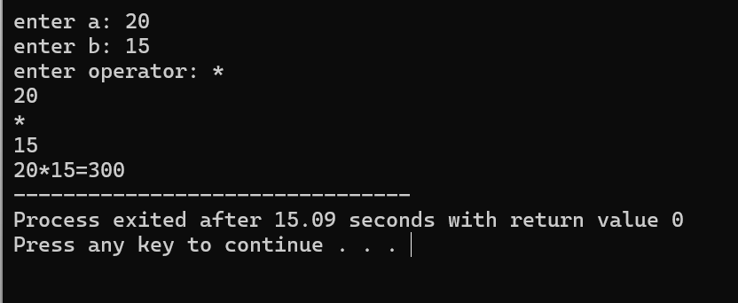

TASK 4.5:
Find the error and show the output of the following code.

CODE:
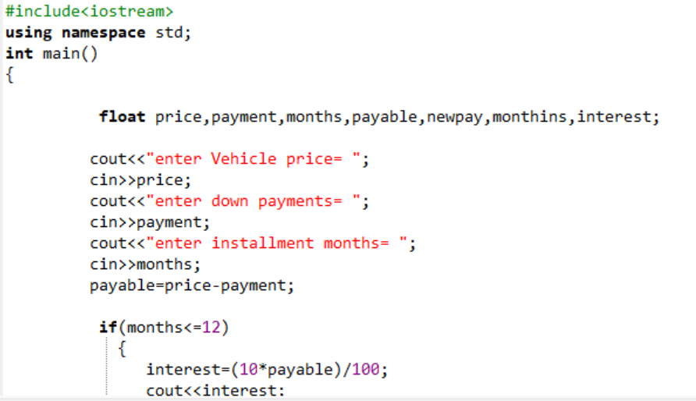
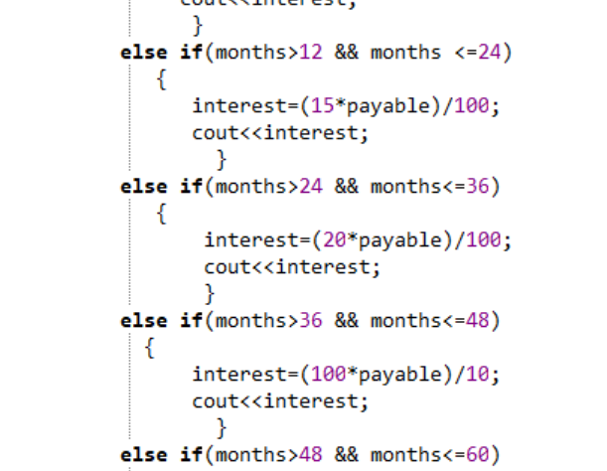
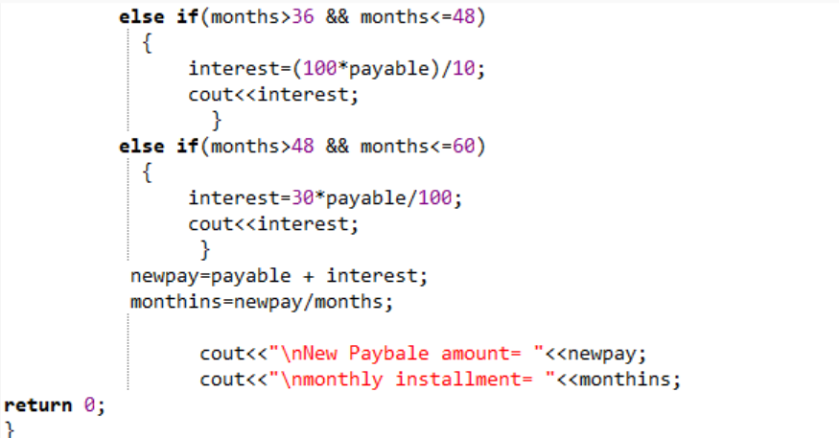
OUTPUT:
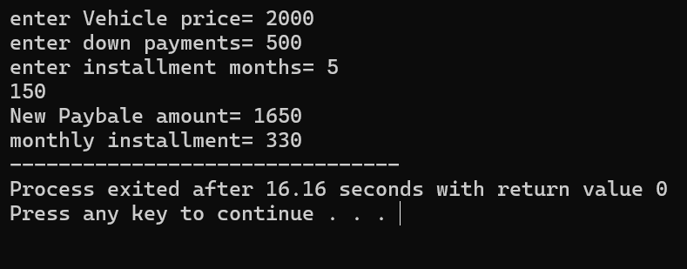

TASK 4.6:
Find the error and show the output of the following code.

CODE:

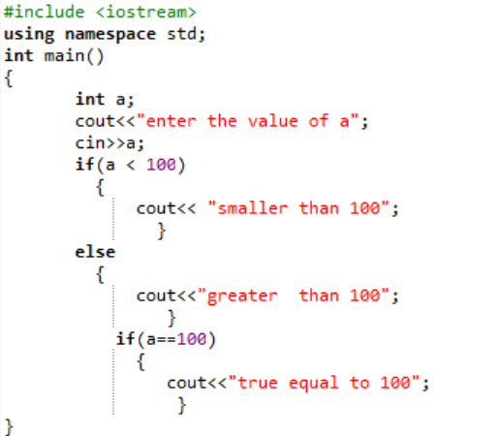

OUTPUT:
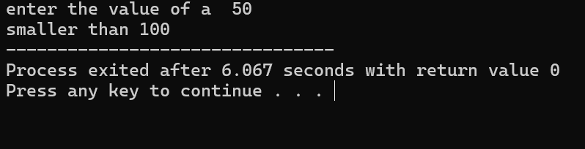
TASK 4.7:
Write a C++ program that calculates the final price of an item after applying a discount. Prompt the user for the original price and apply a 10% discount if the original price is greater than $100; otherwise, apply a 5% discount.

CODE:
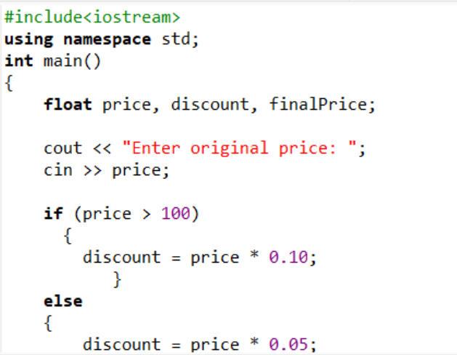
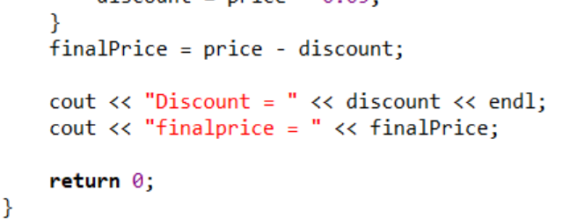

OUTPUT:
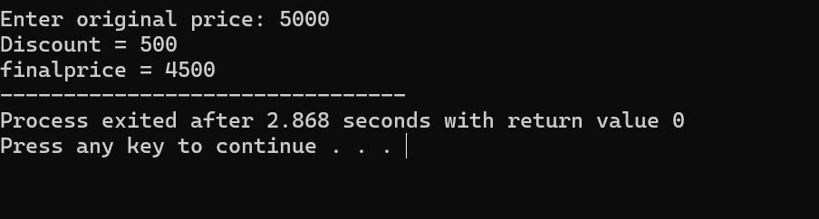

TASK 4.8: Develop a C++ program that classifies a person into different age groups based on their age. Prompt the user for their age and use if-else statements to categorize them into child, teenager, adult, or senior.

CODE:
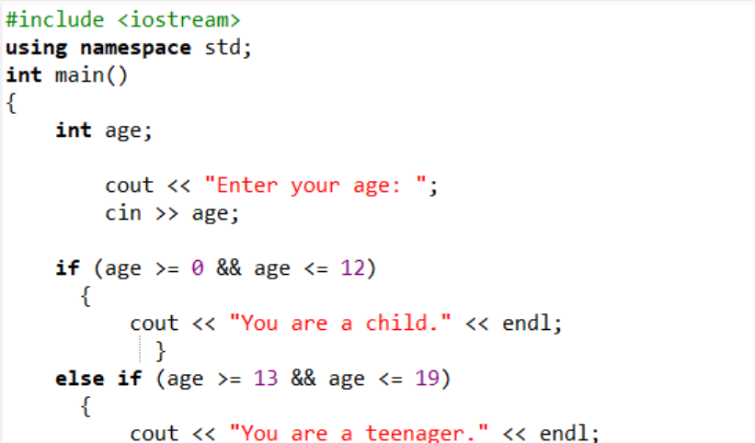
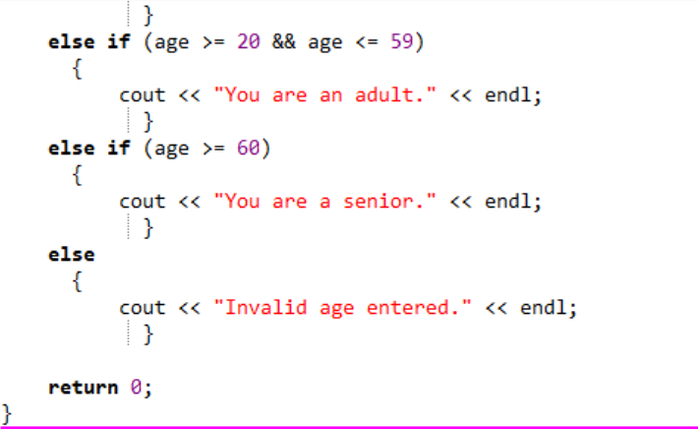

OUTPUT:
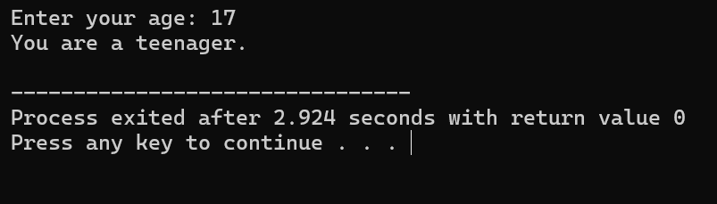

EXERCISE 4.1:
A shop will give a discount of 10% if the cost of the purchased quantity is more than 1000. How much will you save on your purchase? Please enter the quantity you want to purchase. Assume that one unit costs 100. After you input the quantity, I will calculate the total cost and let you know how much you'll save with a 10% discount if the total cost exceeds 1000.

CODE:
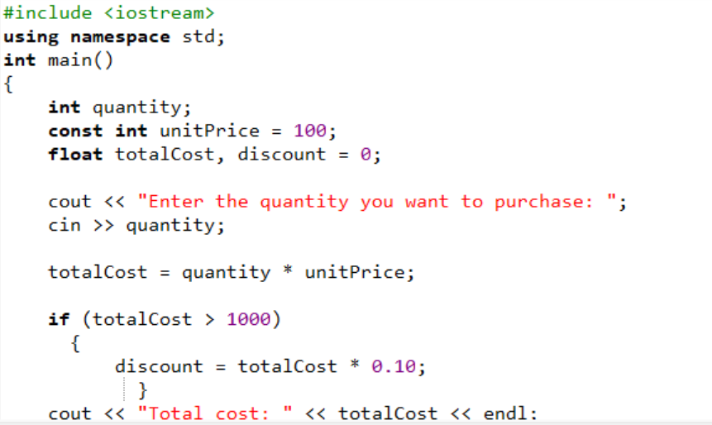
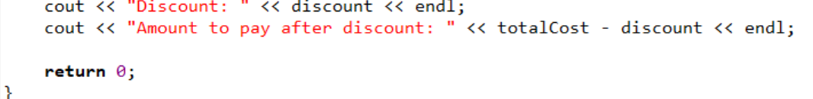

OUTPUT:
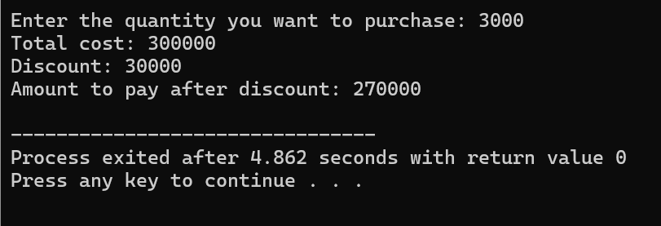

EXERCISE 4.2:

CODE:

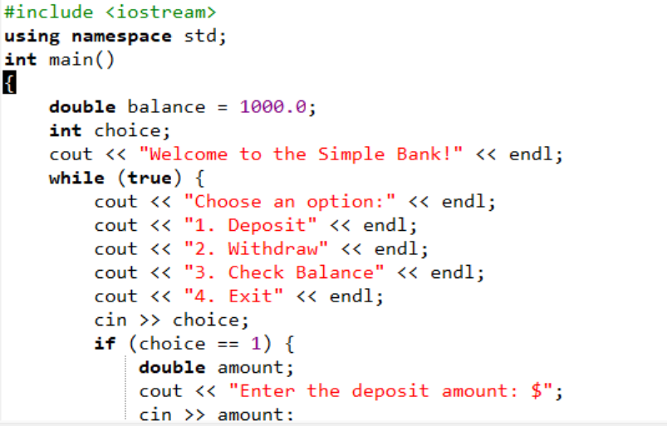
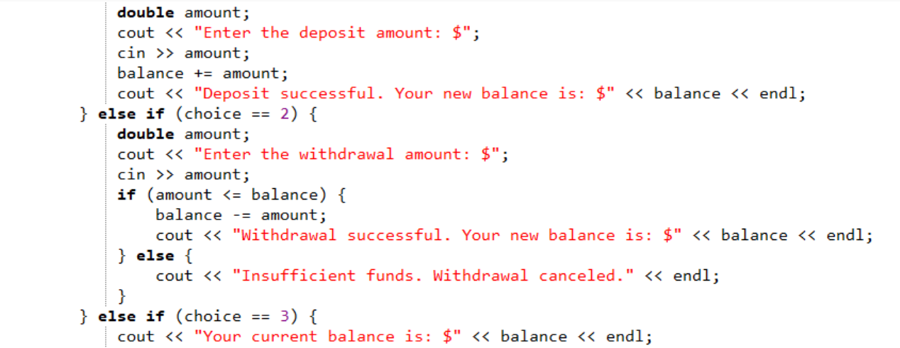
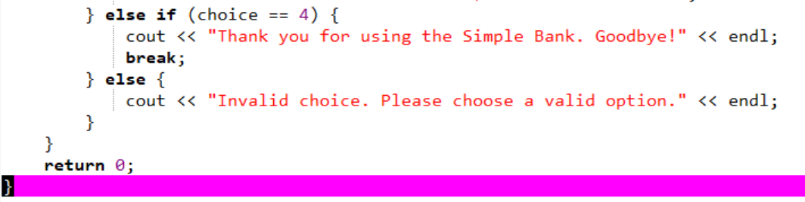

OUTPUT:
